#131

Customer(s):
General Tech  Grade Customer  In Giles  MAGRICULTURE Bags | 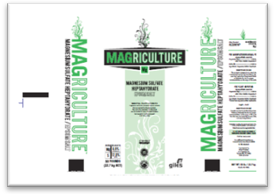

Product: T50SMO-MAG
- Tech Grade |  | - USP Grade | - Liquid
- Screened 20/60 |  | - Screened 60 | - Other
 |  | ( screen out dust )
- Take Samples -

Production / Packaging:
Type of Film - | Giles Magriculture - 50-lb Film |  |  |  |  |  | Weight per Bag | 50-lbs
Number of Bags per pallet |  |  | 49 |  | Pallet Configuration |  | 7 X 7
Type of Sacks - |  |  |  |  |  |  | Weight per Bag
- Shrink Wrap - |  | - Date, Time & Lot # on each Bag |  |  |  | - Number and Initial each pallet
- Liners Required - |  | - Bottom Tie Grommets |  |  |  | - Super sack Tags
- Placards or Tags Required -
- Stickers Required -
- Other Requirements -

Shipping:
- General - | Load according to Giles loading chart and quantity on Bill of Lading
- Air Bags |  | - Double Wrap | - Corner Boards | -
- Must have Quality Approval before loading |  |  | - Must have Management Approval before loading
- Other -

Revision History:

Date | Change
11/06/12 | New Film

